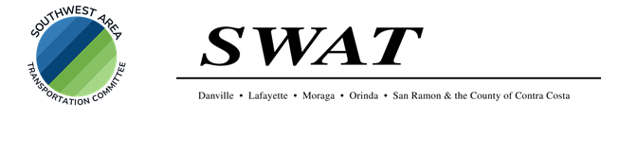

## The regularly scheduled

## Southwest Area Transportation (SWAT) Committee Meeting

for

## Monday, May 5th, 2025

## is

**CANCELLED**

**This next SWAT meeting is scheduled for Monday, June 2nd, 2025 at 3pm. The meeting will take place at the**

**Contra Costa County Board of Supervisors’ Office - District 2 (Candace Andersen) Lafeyette Office at 3338 Mt. Diablo Boulevard, Lafayette, CA 94549**

**And**

### Virtual Teams Meeting